Name of Teaching Staff : Ms.Priyanka Ramesh Patil  Designation : Lecturer  Department: Electrical |  |  |  | 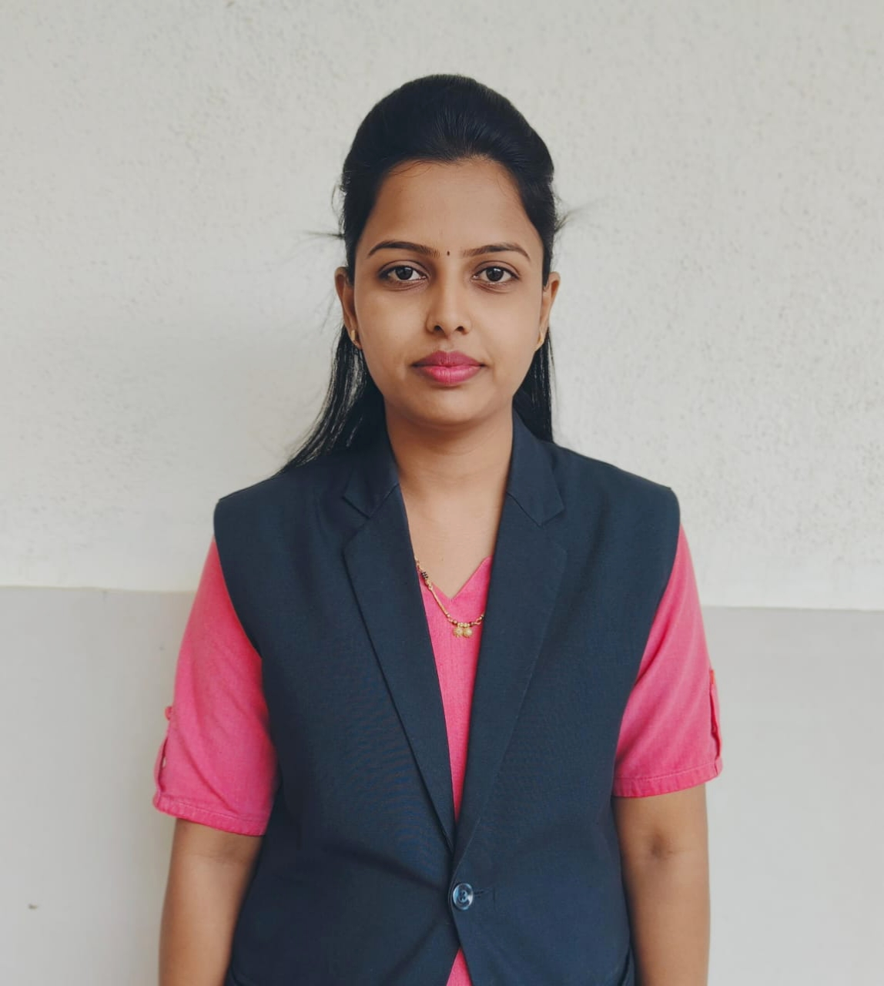  Signature :- 
Official Email Id: prpatil.electrical@jcep.edu.in

Contact Number : 7743884719

Date of Birth | 10/05/1993
Unique ID
Education Qualification | UG- BE (EE) Ist  Class With Distinction
Work Experience - | Teaching-1.5 Years
Area of Specialization | AC Machines in Electrical Engineering
Courses taught at | Under Graduate-DC Machine,AC Machine,Electrical and Electronic Measurement,Electrical Material And Wiring Practice.
No of Papers Published | National Journals: | National Conferences : |  |  | International Journals : |  | International Conferences: 01
Research guidance | - Master - |  |  |  | - Ph.D. -
Projects Carried out
Patents | ------
Technology Transfer | ---
Research Publications
No of Books Published
with details
No. of Workshops  Attended | 02
Professional  Memberships | ISTE- LM142674

