Name of Teaching Staff : Ms. Aditi Anil Jadhav  Designation : Lecturer  Department: Electrical |  |  |  | 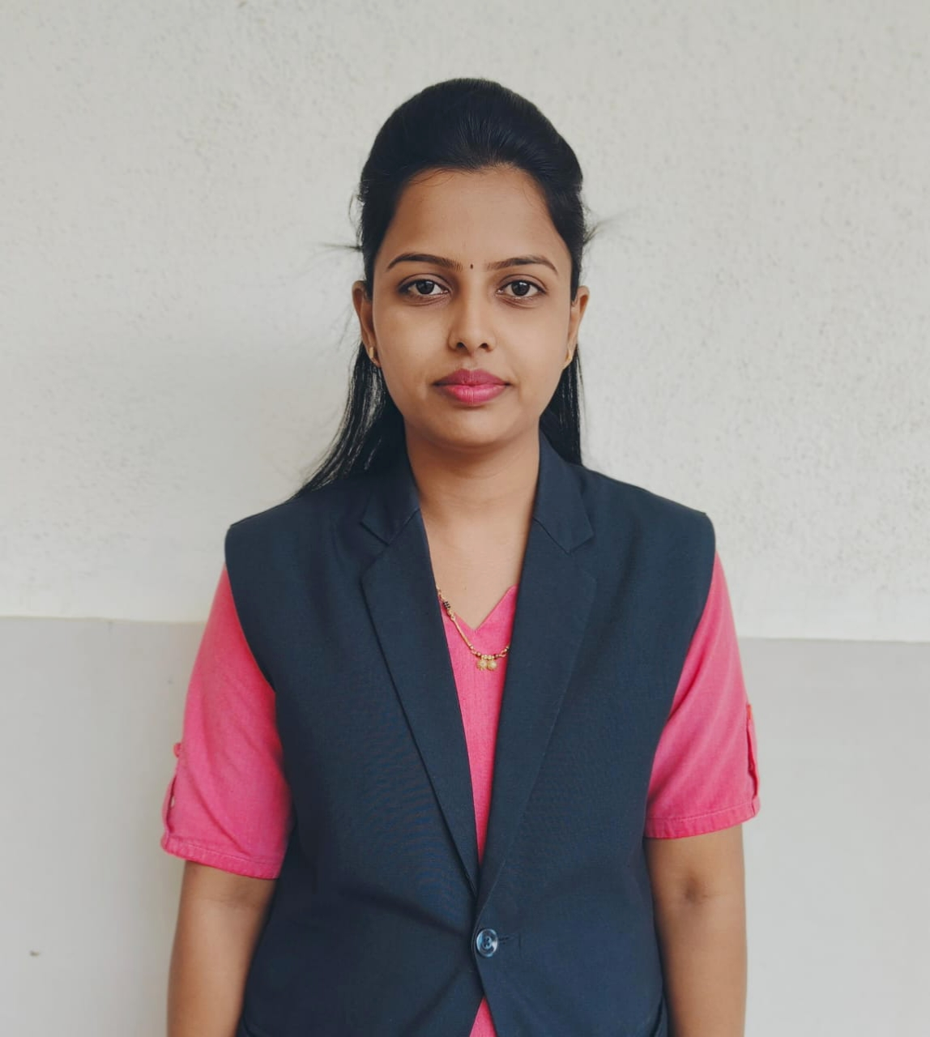  Signature :- 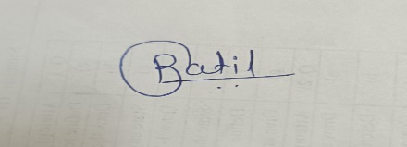
Official Email Id: aajadhav.electrical@jcep.edu.in

Contact Number : 8975406506

Date of Birth | 16/08/1995
Unique ID
Education Qualification | UG- BE (EE) Ist  Class With Distinction
Work Experience - | Teaching- 6 month
Area of Specialization | in Electrical Engineering
Courses taught at | Under Graduate-DC Machine,AC Machine,Electrical and Electronic Measurement,Electrical Material And Wiring Practice.
No of Papers Published | National Journals: | National Conferences : |  |  | International Journals : |  | International Conferences: 01
Research guidance | - Master - |  |  |  | - Ph.D. -
Projects Carried out
Patents | ------
Technology Transfer | ---
Research Publications
No of Books Published
with details
No. of Workshops  Attended | 02
Professional  Memberships | ISTE- LM142674

