Name of Teaching Staff: Ms. Rutuja A Pisal  Designation: Lecturer  Department: General Science & Humanities |  |  |  | Photo  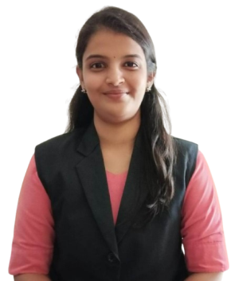  Signature :-  
Official Email Id: rapisal.gsh@jcep.edu.in

Contact Number: 9021633785

Dateof Birth | 22/12/1997
Unique ID
EducationQualification | UG-B.Sc( Maths) Ist Class  B.Ed (Distinction) |  | PG-M.Sc(Maths)  (Distinction) |  |  | PhD -
Work Experience- | 3.6 Years
Area of Specialization | Mathematics
Courses taught at | Under Graduate:  Engineering Mathematics III, Discrete Mathematics ,Probability Theory & Random Processes, Probability & Statistics
No of Papers Published | National Journals: | National Conferences: |  |  | International Journals : |  | International Conferences:
Researchguidance | - Master- |  |  |  | - Ph.D.-
Projects Carried out
Patents | ------
TechnologyTransfer | ---
ResearchPublications | -
No of Books Published  withdetails | -
No.ofWorkshops  Attended | 4
Professional  Memberships | ISTE(LM 142602)

