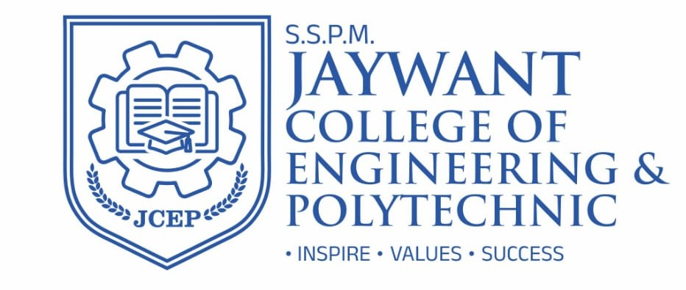

FACULTY - PROFILE

Department | Mechanical Engineering Department |  |  |  |  |  |  |  | 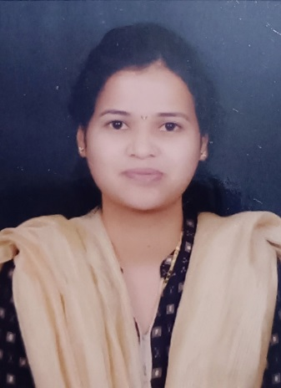
Designation: | Assistant Professor
Name of Faculty: | Ms.Surekha Gorakh Dalavi
Date of Birth: | 26/03/1992 | Date of Joining: |  | 3rd Aug, 2015
Qualification with Class/Grade | UG | PG |  | Ph.D.
Qualification with Class/Grade | B.E. (Mech. Engg.), | M.Tech (Mechanical Material Science & Metallurgy) |  | -
Area of Specialization: | Material Science & Metallurgy
Total Experience in Years: | Teaching |  | Industry |  |  |  |  | Research
Total Experience in Years: | 10 |  | -
Mobile No. (Optional) | 9561806854 |  | E-mail ID: |  |  |  | Sgdalavi.mech@jcep.edu.in
Number of PhD, M.Tech ,  B.Tech Project Guided | UG: 4 |  |  |  | PG: - |  |  |  | Ph.D. : -
Professional Society Memberships | Life Member of Indian Society for Technical Education.
Paper Published in  Journals | National: 00 |  |  |  | International: 5
Paper Presented in Conferences | National: 00 |  |  |  | International: 00
Books/Chapters/ Patents /  Copy rights Published | Books: -0 | Chapters:-0 |  |  | Patents: 0 |  |  |  | Copyrights: -0
STTPs, FDPs, Workshops attended | STTPs: 04 |  | FDPs: 06 |  |  |  |  | Workshops:02
Webinars & Seminars  attended | Webinars:03 |  |  |  |  | Seminars:03
STTP, FDP,Webinar & Seminar conducted | STTP: | FDP: 01 |  |  | Seminar: |  |  |  | Webinar:01
Resource Person Work
Details
NPTEL/Swayam/NITTR/ MOOC/ Other courses | NPTEL : 2 ATAL: Nil
Awards/Recognitions
Consultancy Activities
Google Scholar Link
Google Site/Website link

