Name of Teaching Staff: Mr. Shubham Ramesh Bharamgonda  Designation: Assistant Professor  Department: Electrical |  |  |  | 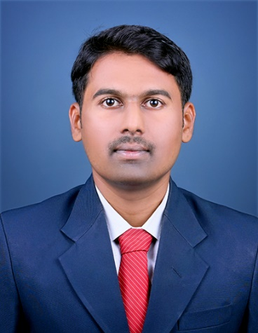  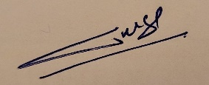
Official Email Id: tpo@jcep.edu.in

Contact Number: 8551045371

Date of Birth | 01/06/1997
Unique ID
Education Qualification | UG- B-Tech (Electrical)- 1st class with Dist. |  | PG-M-Tech. (Electrical Engineering) Appeared
Work Experience - | Teaching- 4 Years |  | Industry- Nil
Area of Specialization | Electrical Machines
Courses taught at | Industrial AC machines, Electric Motors and Transformers, DC Machines and Transformers
No of Papers Published | National Journals: | National Conferences: 01 |  |  | International Journals : | International Conferences:  00
Research guidance | - Master - |  |  |  | - Ph.D. -
Projects Carried out | B-Tech- Smart Water Distribution with Disaster Management  M-Tech- Battery Management System for Electric Vehicle
Patents | ------
Technology Transfer | ---
Research Publications | -
No of Books Published  with details | -
No. of Workshops/FDP  Attended | 07
Professional  Memberships | ISTE Life Membership

